**PROJECT REFLECTION**  
a. What is the URL of your assignment?

[https://CMST385-jahamad.azurewebsites.net](https://cmst385-jahamad.azurewebsites.net/)  
  
b. What issues or challenges did you face completing this project?

The challenges were trying to get the pictures and text to align and to find the right code.  
c. What software programs did you use to create this project?

I used Notepad++  
d. Where did you get your images from?

I got my images on google.  
e. Include the validation information for your HTML5 and CSS validation you completed for this assignment.

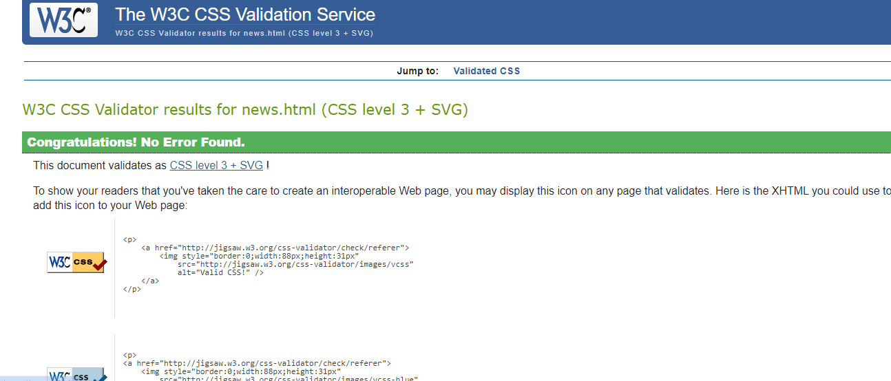

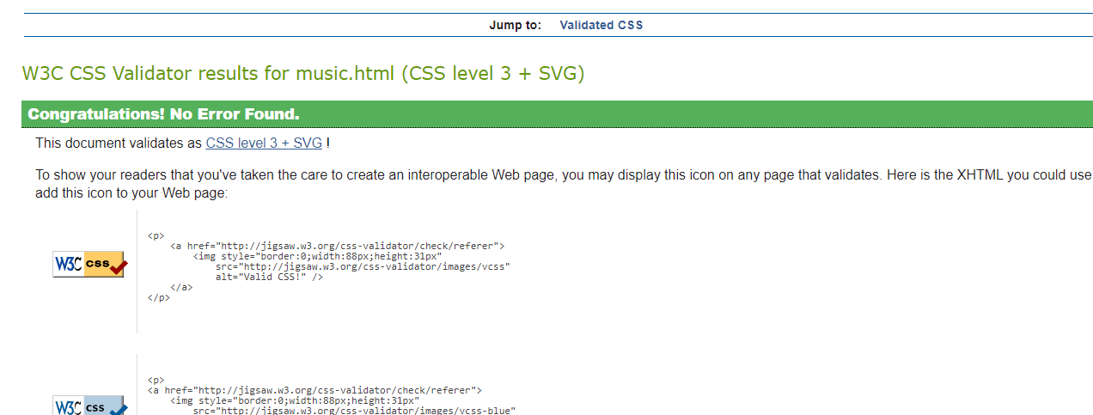

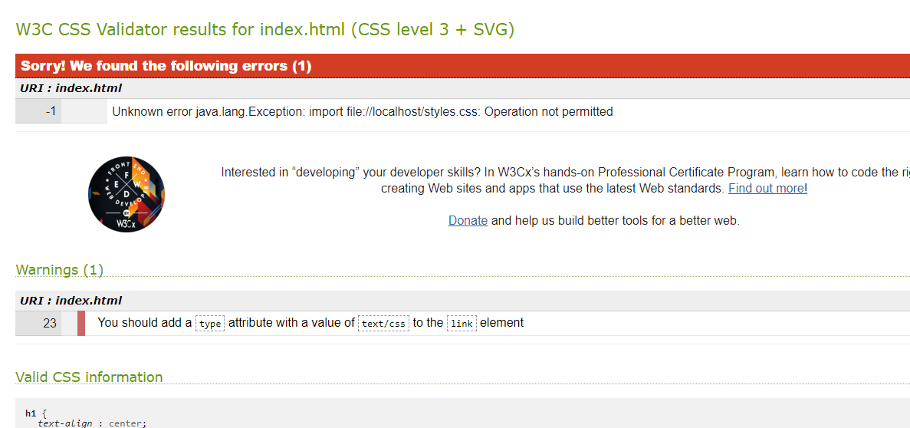

This one said there was an error but I do not know how to fix it and where exactly the error is.